

_________________________________________________________________________

Private Foundations

© 2016 Greene Consulting Associates, LLC INTENDED SOLELY FOR USE BY REGISTERED USERS NOT TO BE REPRODUCED OR CIRCULATED

ABOUT GREENE CONSULTING ASSOCIATES, LLC
Greene Consulting Associates was founded in 1979 and provides consulting and training services solely to the financial services marketplace. Located in Atlanta, Georgia, Greene Consulting has worked with the top providers of investment management and wealth management in both the United States and abroad. Focused on helping firms generate incremental revenue growth through more effective sales and relationship management strategies, Greene Consulting offers customized training programs in Financial Services Sales, a Sales Management program, Presentation Training that integrates proprietary products, and the comprehensive suite of online learning modules related to investments and wealth management entitled SkillMark®.
For more information about Greene Consulting or any of its products and services, write Greene Consulting at Waterstone Building, 4751 Best Road, Suite 450, Atlanta, Georgia 30337. Or, visit the company's website at www.greeneconsults.com or the online training site at www.skillmark.com.

Introduction
Although most often associated with the super-rich, private charitable foundations are an important tool used increasingly by individuals and families of more ordinary wealth. This module reviews the fundamental aspects of private foundations: how they can be used, the benefits they offer, when a private foundation might be considered, and some of the limitations involved.
Objectives
After learning the topics in this module, you will:
- Understand the background of Private Foundations and their purpose as charitable vehicles
- Have a clear perspective of the types of clients who should consider establishing a Private Foundation
- Be able to identify situations where creating a Private Foundation might be especially appropriate
- Be able to identify the steps involved in establishing a Private Foundation
- Understand the key rules regarding Private Foundations, such as restrictions on investments and contributions
- Understand the benefits of Private Foundations, especially their tax benefit

Subject Matter Partner
This course was developed by Greene Consulting Associates, LLC in partnership with Roger D. Silk, Ph.D., CFA, who served as the subject matter expert for this course. Dr. Silk is CEO of Sterling Foundation Management, LLC, a firm specializing in the administration and management of private foundations. Sterling has a program for working with financial planners and their clients to provide turnkey foundation management services. Sterling welcomes inquiries from readers who would like to learn more about how they might participate in this program. Dr. Silk can be contacted at RogerSilk@Sterlingfoundations.com.
Note: Greene Consulting Associates, LLC has partnered with industry leading experts to act as subject matter experts on various topics such as Private Foundations. While his expertise and credentials are evident, to avoid the appearance of any bias or conflict of interest, GCA is not directly affiliated with Mr. Silk or Sterling Foundation Management beyond the development of this and other courses.

The Prevalence of Private Foundations
Private foundations have long been the vehicle of choice by which the extremely wealthy have conducted their charitable activities. Among the best known, and largest, private foundations are the Ford Foundation, the Getty Trust, and the Rockefeller Foundation. But there are also thousands of smaller, less well-known private foundations in existence, controlling in aggregate billions of dollars. While historically associated with the wealthiest in society, private foundations are increasingly a viable and effective alternative that should be considered by affluent clients who are seeking to "give back" to the community while taking advantage of numerous tax advantages designed to stimulate philanthropic intent.
Private foundations control a great deal of philanthropic wealth, and also represent an important component of philanthropic giving each year. Although exact current statistics are not available (because of lags in IRS reporting), there are approximately 50,000 grant-making private foundations in the US, controlling approximately $300 billion in assets (this number, of course, fluctuates daily). Each year private foundations contribute about $15 billion to various public charities.

What is a Private Foundation?
A private foundation is classified as an Internal Revenue Code 501(c) 3 entity, which qualifies it as a tax-exempt charity funded and controlled by one or more individuals or a family. The purpose for developing these entities can be varied, but the common denominator is the desire of an individual or family to utilize a portion of their wealth to fulfill their intent to better the world relative to specific issues to which they are committed. Most foundations function as general-purpose endowment funds that the families use to make their charitable contributions.
The basic activity of a private foundation is simple, consisting of four elements:
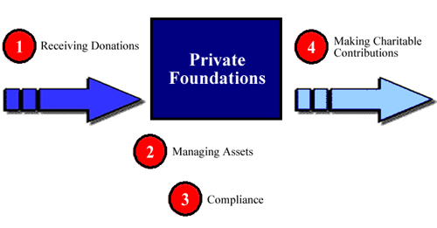
Receiving Donations
While typically from the founder of the foundation, usually donations can be made by anyone. These donations are tax deductible, with no subsequent income tax on the income earned by the foundation. There are, however, some restrictions on the types of assets that can be gifted, which will be discussed later in this course.

Managing Assets
Private foundations are designed for longevity and therefore do not typically disburse the entirety of the assets. Any assets left in the foundation need to be invested. Investment management is typically done by professional advisors, but can be done by the directors themselves.

Compliance
There are significant tax and regulatory requirements that must be adhered to with a Private Foundation. Because these issues can be quite burdensome, many foundations outsource this administrative function to professional advisors.

Making Charitable Contributions
In return for the significant tax benefits offered by private foundations, the foundation must make charitable distributions to public charities each year. These contributions must generally be at least 5% of the foundation's assets.

Financial Benefits of Private Foundations
While private foundations offer a number of benefits, tax benefits alone are not a sufficient reason to create a foundation. A would-be foundation creator must be interested in supporting charity, either immediately or at some time. But given some charitable intent on the part of the founder, there are a number of substantial financial benefits to creating a foundation.
Among the financial benefits of private foundations are the following:
1. Immediate income tax deduction
One of the most important and often recognized benefits of a private foundation is the immediate income tax deduction that can be realized from the assets transferred to these vehicles. However, there are certain limits associated with this benefit that are discussed on the next page

2. Avoid capital gains tax
If the contribution is made in the form of long-term appreciated stock, the donor does not have to pay capital gains taxes on the contributions, thereby maximizing the value of the gift.

3. Income-tax-free growth
Private foundations may earn income without owing income tax, providing the ability to grow assets in the foundation on a tax-free basis. Tax-free compounding, of course, is a very powerful tool that facilitates long-term growth of assets, thereby allowing the grantor to make more significant grants in the future

4. Complete avoidance of all transfer taxes
All contributions to qualified charities are exempt from transfer taxes. This includes contributions to private foundations. Hence, all contributions, whether made during life or upon death, to private foundations are outside of the donor's estate, and therefore free of any gift tax, estate tax, or generation skipping tax. This is particularly important when considering the long-term intergenerational accumulation of wealth for charitable use.

Limits on Tax Deductibility of Donations
There are limitations on the amount of the charitable deduction that can be taken in a given year from income taxes for donations to a private foundation. Donations that exceed these limits may be carried forward for income tax deductions in future years.
These limits are as follows:
1. Limited to 30% of AGI
Deductions for contributions to private foundations are limited to 30 percent of the donor's annual adjusted gross income (AGI). This 30% limit is an overall limit.

2. Long-term appreciated publicly traded stock limited to 20% of AGI
Donors contributing long-term appreciated publicly traded stock to a private foundation may deduct such contributions up to 20% of their adjusted gross income (AGI). To receive a deduction based on fair market value, the donor must have held the stock for more than one year, and the stock must be traded on an exchange.
In other words, the deduction on combined contributions of all types is capped at 30% of AGI, of which no more than 20% of AGI can be for contributions of long-term appreciated property. The deductibility of contributions beyond these limits can be carried over for 5 years.
For example, a donor may get a deduction for up to 30% of AGI by giving 30% in cash. If the donor gives long-term appreciated property instead of cash, then only 20% of AGI could be deducted. If, however, the donor gives10% in cash and 20% in long-term appreciated property, then the combined contributions would be deductible because they do not exceed 30% of AGI [ref. Sec. 170(b)(1)(D)].

Advantage of Gifting Long-Term Appreciated Securities
To the degree that it is possible, it is more beneficial to gift long-term appreciated property than to gift cash. The advantage of giving long-term appreciated securities is twofold. First, the deduction for the full fair market value is usable against ordinary income. Second, the unrealized capital gain is not subject to income tax when the foundation sells the securities.
The illustration below shows that this benefit is quite significant. Suppose the donor wished to make a $100,000 contribution using long-term appreciated securities that had doubled in value since purchase. If the donor had to recognize and pay capital gains when making the contribution, it would require $111,112 worth of securities to make the contribution; but by being able to gift the securities directly to the foundation, only $100,000 worth of securities is needed. Both scenarios provide the same charitable deduction for income tax purposes.
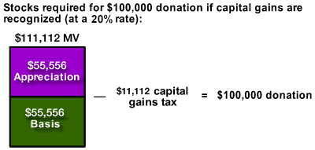

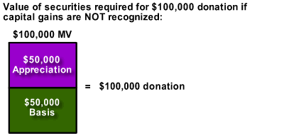

Review Exercise
Select the correct answer to each question.
The following case study serves to provide clarification to some of the preceding concepts.
Mrs. Reece Johnson has devoted many hours of her time to help raise funds for various religious and missionary organizations. With the recent sale of her technology company, she has expressed intent to "give back to the community". Her AGI for this year is $4.2 million and she expects that to stay about the same for the next 5-7 years based on royalty payments she is receiving from the sale. She currently holds about $4 million in unrestricted stock in Seibel (SEBL) with a basis of $1.2 million and has $1.5 million in cash, the bulk of which she wishes to give to charity, but wishes to proceed in the most tax-effective manner possible.
- Does a Private Foundation make sense?
- Yes
- No
- Are there any limitations to her deductions?
- No limitations
- Current deduction limited to 15% of her wealth
- Current deduction limited to cash contributions only
- Current deduction limited to 30% of her AGI
- Given only the information that she wants to maximize the income tax deduction related to her gift, what would be the most advantageous strategy for initially funding the Private Foundation?
- Give $1,260,000 in cash
- Give $1,260,000 in long-term appreciated stock
- Give as much stock as she is willing to gift in this year
- Seek something other than a Private Foundation for the gift

The answers to these questions are found on the following page.

Review Exercise – Answer Key
Select the correct answer to each question.
- Does a Private Foundation make sense?
- Yes
Correct. A Private Foundation would seem to be a good fit for this situation based on the size of the intended gift and the overall amount of wealth held by this individual.
- No
Incorrect. While a Private Foundation is not effective in every situation, the size of the intended gift and the overall amount of wealth held by this individual would seem to make it appropriate here.
- Are there any limitations to her deductions?
- No limitations
Incorrect. Remember that deductions to Private Foundations are limited to a percentage of AGI. Try again.
- Current deduction limited to 15% of her wealth
Incorrect. Deductions are limited based on AGI, but the percentage is not 15%. Try again.
- Current deduction limited to cash contributions only
Incorrect. Deductions of cash and assets are acceptable for Private Foundations. Try again.
- Current deduction limited to 30% of her AGI
Correct. Her deduction for any gift is limited to 30% of her AGI or in this case $1,260,000.
- Given only the information that she wants to maximize the income tax deduction related to her gift, what would be the most advantageous strategy for initially funding the Private Foundation?
- Give $1,260,000 in cash
Incorrect. Remember that there are tax advantages related to the use of long-term appreciated stock assets in the gifting to a foundation. Try again.
- Give $1,260,000 in long-term appreciated stock
Partially Correct. While this is more advantageous than the cash gift, there is a better option if she wants to maximize the longevity and value of the gift. Try again.
- Give as much stock as she is willing to gift in this year
Correct. Give as much stock as she is willing to gift in this year. This may be the most appropriate strategy if her intent is to maximize the value of her gift. First, she avoids capital gains taxes on the gift when using appreciated securities. Second, she is able to carry any unused deduction forward for up to 5 years. Third, she is able to benefit from the income tax free growth of the contribution inside the Private Foundation, thereby extending the total value of the gift over time. Fourth, the assets that are gifted to the foundation are taken out of her estate and are therefore not subject to estate taxes. As such, she has fulfilled her intent, established a potentially perpetual gifting strategy and has received extensive tax benefits, both now and into the future.
- Seek something other than a Private Foundation for the gift
Incorrect. This situation is almost ideal for the use of a private foundation. Try again.

Structural Benefits of Private Foundations
While the direct financial benefits of a Private Foundation make a compelling case in and of themselves, there are also other structural benefits related to utilizing these vehicles.
1. Personal Satisfaction
Personal satisfaction is perhaps the single overriding reason why the people ultimately create private foundations. Although relatively few donors will come right out and admit it, most tend to be very appreciative of the attention, social status and other intangible rewards which are associated with being known in the community as a significant donor. Private foundations maximize this recognition because, as a named corporate entity, they provide perpetual name recognition for those with long-term philanthropic intent. Of course, deep, lasting satisfaction also comes from making a difference in people's lives.

2. Flexibility
Unlike all other alternatives for charitable giving, private foundations allow their creators to maintain maximum flexibility. Since donors retain control over the way that their assets are invested, when money will be given to charity, which charities money is given to, and how much, the private foundation enables donors to adapt their charitable behavior as their needs and circumstances dictate.

3. Control
Control of assets is very important for most high net worth individuals. In many cases, this carries over into their charitable activities as well. The private foundation rules allow a foundation creator to retain complete legal control over the foundation and its assets during life, and to pass that control to chosen successors in perpetuity. It is for this reason, probably more than any other, that private foundations continue to be the vehicle of choice for most wealthy donors.

4. "Buy Time"
The great majority of successful people have a strong desire and commitment to give something back to society, in one form or another. Most currently give to one or more charities, or plan to do so in the future when they get a little more time to focus on that aspect of their lives. But busy people often face a dilemma. They need a tax deduction this year, but are not yet prepared to make major commitments to specific charities. A private foundation makes it possible to do both. They can get a tax deduction now; yet "buy time" to decide later (even years from now) how to best spend their charitable dollars.
Large gifts to charity are serious business and they deserve thoughtful attention. The flexibility of a private foundation, and the requirement that the foundation give only five percent of its assets each year to charity, enable donors to take advantage of the tax breaks, yet still provide themselves with the opportunity over time to devote the attention that large gifts deserve

5. Involve Family with Charitable Intent
Many people use private foundations as a way to communicate and instill common values and ideals in their children and grandchildren by involving them with the management and administration of the foundation. The formal structure of a private foundation provides a very natural framework for involving children, for example, as directors. Many foundation creators choose to involve their children informally for a period during which they evaluate each child's level of interest, involvement and commitment. There are, of course, many different approaches and no single approach can be said to be right for all founders. In some cases, the children may become seriously involved and the foundation directors may choose to pay these children reasonable salaries for the work they perform.

When To Use Private Foundations
Clients who have any plans at all to give money to charity now or in the future (including upon death), and who are financially qualified, should consider creating a private foundation now. Failure to do so will almost certainly waste precious charitable dollars by paying too much in taxes.
In evaluating whether a foundation might be appropriate for a client is important to consider both the client's charitable goals and the financial situation.

Charitable Goals to Consider
Many clients, particularly those who have not previously considered a private foundation, may be relatively unclear in their own minds as to their charitable goals. While this can present something of a challenge, there are several rules of thumb, or key items to look for. The following is a brief list of some of these key items:
Key Charitable Goals
- A desire to create a unique and perhaps permanent legacy;
- A desire to teach their values and share their vision with children/grandchildren;
- A desire to maintain flexibility to adapt charitable activities as the client learns more and as circumstances change;
- An interest in maintaining legal control over charitable assets;
- The desire to give, yet remain anonymous;
- A desire, whether articulated or not, to "make a difference."

Determining Financial Qualification
While a private foundation is a very powerful tax-saving tool, it is not for everybody. Generally speaking, in most cases a client should have at least a net worth of $5 million or annual income of $500,000 to be considered a likely candidate for a private foundation during life. Additionally, due to the setup and administrative costs involved, in most cases a client should expect to fund his foundation eventually with at least $500,000 in order to be considered a likely candidate. However, the client need not plan to put the full half-million in immediately.

Situations in Which Creating a Foundation Might Be Especially Appropriate
The following is a list of specific economic situations that particularly suggest creating and funding a private foundation. Clients who experience any of these economic situations should consider a private foundation:
Appropriate Situations
- A particularly high income in a year;
- Steady, or growing, income above personal needs;
- An intent to endow a private foundation at death;
- Client currently gives a significant amount to charity each year;
- Client owns highly appreciated, publicly traded stock;
- Client's net worth exceeds the amount he or she anticipates needing;
- Ownership of the appreciated stock of a particularly volatile company;
- Ownership of a large block of appreciated, thinly traded public stock;
- A plan to leave a substantial amount of assets to charity upon death.

Costs to Set Up and Maintain a Foundation
The cost to set up and maintain a private foundation is the main reason most people do not use them for amounts less than $500,000. Like many professional services, the costs to create a foundation may vary considerably between providers. A typical charge to create a private foundation will exceed $20,000.
Ongoing maintenance depends largely on the size and activity of the foundation. Costs may range from about one percent of assets for well-run, lean foundations, up to five percent or more. It is possible to run a foundation on a shoestring; but it is important in such cost-driven modes to pay particular attention to the full spectrum of compliance issues, some of which may be overlooked in the effort to minimize the costs of managing the foundation.

Key Rules Regarding Private Foundations
Although the benefits of a private foundation are compelling, and the activity of a private foundation is conceptually simple, the compliance and accounting aspects can be quite burdensome. Furthermore, the penalties for failing to comply with all the relevant requirements can be quite severe. For these reasons, professional management may be advisable.
Congress recognized that private foundations have a tremendous amount of appeal to wealthy people. Because of perceived abuses of private foundations, which occurred many years ago, Congress has placed a number of restrictions and requirements on private foundations. Although the details of these are very complex, and compliance with them can be burdensome, the basics are fairly straightforward. Although all foundations must follow all the rules, in practice the real impact of the rules is simply to create paperwork. The following is a list of the most important of these requirements and restrictions.
- A prohibition on "self-dealing"
- A prohibition on "excess business holdings"
- A prohibition on "jeopardy investments"
- Required annual distributions
Generally, these limitations do not affect the achievement of a founder's goals, provided that care is taken to ensure that none of the relevant rules are violated. The specifics of the rules are quite complex, and the following pages are intended as an outline only and should not be relied upon as legal advice.

Rules Against Self-Dealing
Broadly speaking, the prohibition on self-dealing [Section 4941] means that disqualified persons [Section 4946] - generally the founder and lineal descendants and antecedents (e.g. parents and children), and people under their employment - may not engage in any transactions with the foundation, except to make donations to it or, under limited circumstances, to receive fair market value compensation for services [Section 4941(d)2].
In general, a donor is never permitted to receive an improper benefit from a charity he or she supports. In the private foundation arena, these rules are spelled out in some detail. A few key rules that founders should be aware of:
A disqualified person may not:
- Use the foundation's assets or its income for his or her own personal use
- Borrow money from the foundation
- Buy things from the foundation or sell things to it
- Keep foundation assets (e.g. paintings) on his or her premises
A disqualified person is permitted to have certain, arm's-length dealings with the foundation. For example, the founder and his/her family may receive reasonable director's fees (provided that they do not receive preferential treatment), and the donor and/or family members may be employed, provided that their compensation is reasonable for work actually performed. Specific situations may require specific legal advice.

Excess Business Holdings
A set of rules addressing "excess business holdings" are designed to keep a private foundation from owning a significant stake in a family business. While the excess business holdings tests can become complex, a safe harbor generally provides that founders should not allow their foundation to own more than 2% of the family (or other closely held) business.
As a practical matter, this means that a private foundation cannot be a significant owner of the founder's business. Be aware that while very small stakes in such companies or businesses are permitted, the rules are quite complex, and each case must be looked at individually.

Prohibition on Jeopardy Investments
To prevent private foundations from jeopardizing their principal through excessively risky investments, so-called "jeopardizing investments" are prohibited. While the law does not provide a "bright line" test, this rule is not especially stringent and will usually not constrain any reasonably prudent, diversified investment approach.
For example, even fairly unconventional investments such as futures, options, warrants, hedge funds, and the like may be allowed, but can be subjected to special scrutiny by the IRS¹. If the client's foundation desires to invest in such assets, it would be advisable to consult an expert in advance and have adequate documentation prepared.
A related issue is margin trading. While not strictly prohibited, it is highly inadvisable in a private foundation. While the IRS does not strictly prohibit such margin trading in a foundation account, founders/directors could be personally responsible for any losses incurred while trading on margin. In other words, the risk/reward to such investing in a foundation account is lopsided against the founders/directors (if they make money, the foundation will get the benefit; if they lose money, they may be personally liable to the foundation for the loss). Even if the loss has nothing to do with the margining in the account, the founders/directors put themselves at risk for any loss. Thus, the prudent course is to avoid margin trading.
¹The IRS has, for example, approved investments in nontraditional areas. See PLR 9451067

Requirement to Distribute Income
Private foundations are required to distribute a certain amount of assets to qualified public charities each year. Generally, the amount is approximately 5% of average net assets, less certain foundation costs and expenses such as certain legal and investment management fees. Generally, the distributions must be made in the year following the year upon which they are based. This assures that there is time to calculate the required amounts and make effective decisions as to where to give the required distributions.
In addition to these constraints, there are a number of additional rules and requirements regarding how a foundation is operated, what tax, and other reporting it must do.

Tax Returns
Even though charities generally pay no income tax, they are still required to file income tax returns with the IRS. Private foundations must file a Form 990-PF annually, in addition to certain other forms that may be required from time to time. Portions of the 990-PF are public and must be made available to the public on demand.
The requirement to file tax returns means that very precise accounting is required for private foundations. Even though the amount of tax (from the 2% or 1% excise tax on net investment income) is almost always small, the rules still require that it be calculated properly and paid on a timely basis.

Net investment income
Net investment income is defined as total investment income less expenses required to collect or produce the income. Investment management fees represent an expense required to produce income.

Documentation Requirements
When a foundation makes a gift to a charity, there are certain, specific documentation requirements that the foundation must adhere to. Like many bureaucratic procedures, these are not difficult, but they can be frustrating for someone not familiar with them.
While these rules are complex, a professionally managed foundation should have no problem complying. The following is a brief outline of the major tasks that a manager will need to perform on an annual basis to ensure compliance and smooth running:
Managerial Tasks
- Maintain all required foundation records, including grant documentation.
- Provide donor with proper donation acknowledgements from their foundation
- Ascertain and document proper charitable status of grant recipients
- Provide for performance of all non-profit bookkeeping and accounting
- Calculate each year's minimum required distribution
- Ensure preparation and filing of annual federal and state tax returns
- Assure compliance with restrictions against self-dealing and excess business holdings
- Confirm observance of fiduciary duty against jeopardizing investments
- Monitor changes to IRS provisions regulating private foundations
- Prepare required letters to grant recipients with required language as specified by Internal Revenue Code
- Prepare and transmit grants to recipients

Turn-Key Professional Management Makes Smaller Foundations Feasible
As this course has demonstrated, the administrative and compliance burden of a private foundation can be considerable. However, if a professional firm is retained to provide turnkey management, the process is actually very simple for both advisor and client. To create a foundation, the client really only needs to make three simple decisions. These are:
Founder's Key Decisions
- Decide who is to serve on the board. Only on person is needed, and there is no upper limit. Typically, it is recommended that a founder's initial board consist of the founder, and optionally a spouse and/or children.
- Decide the initial funding. Creating a foundation in one year does not obligate the founder to contribute to it in future years.
- Decide what to call the foundation. Almost any name will work, provided it is available. Quite often, the founder's name or family name is used.

Tax Benefits Illustrated - Case Study Analysis
The following four case studies illustrate the most common situations in which private foundations might be used to capture tax benefits. In any given client situation, creating a foundation will usually result in both an immediate and a longer-term increase in net assets for the client and his foundation. The immediate increase results from the income tax deduction the client receives.
Case Study 1 - Income Tax Benefit in a Single Year
Harold Johanssen is in the 45% income tax bracket (combined federal and state), has $1,000,000 of income (AGI), and is considering whether or not to make a $300,000 contribution to his foundation. He plans eventually to leave 25% of his estate to charity.

- Given only this information, what is his tax burden if he does not make the donation?
- $300,000
- $450,000
- $500,000
- If he does make the donation, what will his tax burden be?
- $315,000
- $450,000
- $500,000
See below for overall analysis of this case.
If he does not make the donation, he will be taxed on the full $1,000,000. He will pay $450,000 in taxes, leaving him a total of $550,000 in assets.
If he does make the contribution to his foundation, he pays tax on just $700,000 of income. His income tax now drops to $315,000, a decrease of $135,000, and his total assets, both personal and foundation, increase by that same $135,000. By making the contribution, he controls total assets of $685,000, instead of just $550,000.

The answers to these questions are found on the following page.

Tax Benefits Illustrated - Case Study Analysis – Answer Key
Select the correct answer to each question.
- Given only this information, what is his tax burden if he does not make the donation?
- $300,000
Incorrect, his tax burden will be $1,000,000 (AGI) x 45% (tax rate) = $450,000. Try again.
- $450,000
Correct.
- $500,000
Incorrect. His tax burden will be $1,000,000 (AGI) x 45% (tax rate) = $450,000. Try again.
- If he does make the donation, what will his tax burden be?
- $315,000
Correct. If he makes the donation, his income tax now drops to $315,000, a decrease of $135,000
- $450,000
Incorrect. His tax burden is lowered because of the gift. His tax is $700,000 (new AGI after gift) x 45% = $315,000 ($135,000 lower than without the gift). Try again.
- $500,000
Incorrect. His tax burden is lowered because of the gift. His tax is $700,000 (new AGI after gift) x 45% = $315,000 ($135,000 lower than without the gift). Try again.

Case Study 2 - Income Tax Benefit is Greater When Long-Term Appreciated Stock is Gifted
Case Study 2 - Benefit of Gifting Long-Term Appreciated Stocks
In case study 1, Mr. Johanssen was assumed to have given cash. The income tax benefit would be even greater if he instead used long-term appreciated stock.
For the sake of example, assume that his $300,000 contribution consists of $200,000 of stock (long-term appreciated property is limited to 20% of Contribution Base, which is typically 20% of AGI), which has a basis of $50,000, and $100,000 in cash. His income tax deduction is still $300,000, and saves him $135,000 of income taxes as in case study 1. But he also avoids a capital gains tax on the $150,000 of unrealized appreciation. Given a 20% capital gains rate, he saves another $30,000 of income taxes.

Case Study 3 - Income Tax Advantages Over Time
Over time, the advantage of the foundation grows because private foundations are not subject to income tax. Properly managed, private foundations pay only a minimal excise tax of 2% on investment income. Let us illustrate the effect of these tax savings by expanding the previous example.
Case Study 3 - Income Tax Advantages Over Time
Suppose Mr. Johansenn is 55 years old and has assets of $12,500,000, which return 8% a year net pre-tax, giving him $1,000,000 of income. Also assume that each year he contributes 30% of his income to his foundation, his foundation earns 8%, makes the required minimum annual distribution, and pays excise taxes of 2% of investment income and foundation management fees of 1% of assets. Assuming all income is interest income and ignoring any living expenses and computing his taxes at a flat 45%, after 27 years his net worth will be $28.4 million, and his foundation will be worth $16.3 million, for a total of $44.7 million.
Contrast that situation to one in which the client has no foundation but makes the same charitable contributions as his foundation would have made. He will have $33.3 million after 27 years. Thus, during the client's life, he can increase the assets under his control by over $11.4 million just by funding his foundation annually.
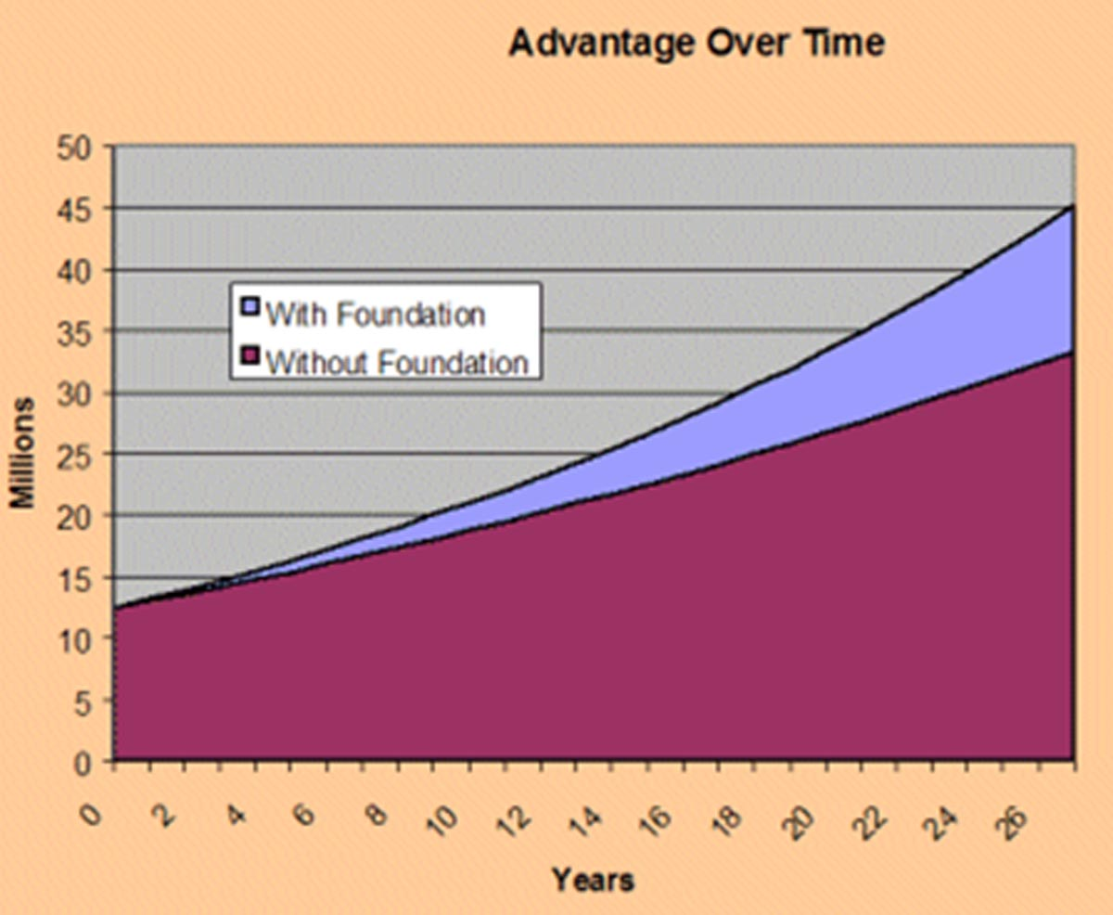

Case Study 4 - The Estate Tax Advantage
The fact that the foundation is not subject to estate tax can also be tremendously important to building and sustaining assets over time.
Case Study 4 - The Estate Tax Advantage
Continuing to explore Mr. Johansenn's situation, suppose he dies at the end of year 27 and leaves no additional assets to charity. Also suppose he has used up his Applicable Credit by making lifetime gifts to children. Assuming current (2016) law, then estate taxes would take approximately 40% of the amounts not in the foundation when Mr. Johansenn dies. The amount in the foundation would not be affected by estate taxes. If he had not funded the foundation during life and waited to contribute 25% of his estate upon death, he would leave 25% of $33.3 million, or $8.3 million to his foundation. Ignoring any tax exclusion that might be available to him, that would leave a taxable estate of $25 million, of which the estate tax would take approximately 40% or $10 million. This leaves just $15 million to his heirs.
In contrast, by funding the foundation annually, the foundation already has $16.3 million, almost twice as much as if he had waited until death. At his death, he leaves his entire estate of $28.4 million, less tax, to his heirs. After paying estate taxes of $11.3 million, the heirs receive $17.1 million, more than they would have received had he waited until his death to fund the foundation.
 | Lifetime Funding | Funding at Death
Estate Taxes Paid | $11.3 million | $10 million
Size of Foundation | $16.3 million | $8.3 million
Amount to Heirs | $17.1 million | $15 million

How to Set Up a Private Foundation
Starting a Private Foundation does require experience and clear understanding of the tax and regulatory issues involved. Historically, some people have tried a "do-it-yourself" approach involving a combination of personal effort and the use of required professionals such as attorneys and accountants. Some version of "do-it-yourself" has been the most popular choice, because full-service management was hard to find or because a bank trust company was not desirable for one or more reasons.
But "do-it-yourself" places a heavy burden on the founder and directors. Because of the complexity of running an effective foundation, a "do-it-yourself" foundation is very likely to be run at best inefficiently and at worst is a violation of the rules. Alternatively, a full service foundation management firm or bank trust company can be hired.
Regardless of the route chosen, the first steps to take with clients wishing to establish a private foundation are to:
First Steps
- Retail legal counsel to draft documents (specifically the articles of incorporation)
- Establish an investment policy (not a regulatory requirement but a standard for effective foundation management)
- Acquire a tax ID number
- Open investment account to accept and hold assets (donations)
- File IRS Form 1023. (Application for Exempt Status Under Section 501(c)(3) of the Internal Revenue Code)

The Private Operating Foundation
While rare, there are some situations where a Private Operating Foundation may be appropriate. While similar to the Private Independent Foundation we have been referring to, the Private Operating Foundation structure is designed for those situations where the founders wish to develop and run their own programs such as education centers, counseling centers, or feed the hungry kitchens. The "operating" foundation does not have the restriction of making grants solely to not-for-profit entities. However, these foundations require significant involvement of the founder (or a staff) and have other restrictions such as the requirement to devote at least 65% of assets to "charitable purposes," distribute at least 66% of minimum investment returns to public charities, or must get substantially all of their support from the general public.

Substantially All
Excluding total investment income, 85% of the support must be received from the general public and “5 or more unrelated exempt organizations” according to the IRS. Other requirements apply.

Summary
For qualified clients, there are tremendous benefits available from a private foundation. These benefits range from immediate income tax advantages, to the unparalleled satisfaction of knowing that you are making the world a better place. A private foundation can add structure and purpose to a donor's charitable activity, allow him to involve family and other important people in the charitable process, and give the donor permanent control over his assets. While the regulations regarding private foundations are extensive, a professionally managed private foundation will allow your client to obtain all the benefits, while avoiding the hassles. That is why more and more people are creating their own private foundations.

Conclusion
This concludes the material for this subject. At this time, you may return to any sections in which you feel the need for further study.

